submit timesheet & create invoice for payment



Document ID | DEV-FIN-SOP-001-v1.0
Product | Finance
Environment | ---
Confidentiality Level | Internal / Restricted

CONTENTS
1 DOCUMENT INFORMATION 3
1.1 Validation 3
1.2 Document Distribution 3
1.3 Version Control 3
2 PURPOSE & CONTEXT 4
2.1 About this document 4
2.2 Scope 4
2.3 Roles & Responsibilities 4
2.4 Terminology 4
2.5 Conventions Used 4
3 SUBMIT TIMESHEET 6
3.1 Submit Timesheet in Hubstaff 6
4 CREATE INVOICE FOR PAYMENT 8
4.1 Invoice creation based on Timesheet 8
5 APPROVAL SIGNATURES 12

DOCUMENT INFORMATION

Validation
Name |  | Role | Date (dd/mm/aa)
Issued by | Oscar Rondon | Technical Writer | 09/01/2026
Verified by | Vishal Bavadiya | Developer
Approved by

Document Distribution
Normal | Role
Oscar Rondon | Technical Writer
Anthony Bures | Digital Development Manager
Vishal Bavadiya | Developer

Version Control
Version | Date | Author | Description of changes
1.0 | 09/01/2026 | Oscar Rondon | First version of the invoice creation process - SOP document

PURPOSE & CONTEXT

About this document
This Standard Operating Procedure (SOP) describes the standardized process for submitting timesheets and creating invoices in Hubstaff to ensure accurate and timely payments from ZTERS.

Scope
This SOP applies to all contractors and personnel who are required to log work hours and generate invoices using Hubstaff for payment by ZTERS.
In scope:
- Reviewing and submitting timesheets
- Creating and submitting invoices based on approved tracked time
- Ensuring accuracy and completeness of submitted records
Out of scope:
- Contract negotiation, pay rates, or payment terms
- Tax, legal, or compliance advice related to invoicing
- Bank transfers, wise account setup, or payroll configuration

Roles & Responsibilities
Role | Responsibilities
Contractor | - Accurately track all work hours in Hubstaff  - Submit timesheets for approval  - Create invoices based on approved tracked time
Project Manager | Approve or reject tracked time with clear feedback
Staff Accountant | Verify invoice completeness and compliance

Terminology
Term Used | Description
Hubstaff | Time-tracking and workforce management platform used to log work hours and generate invoices.
Timesheet | A record of tracked work hours for a defined period.
Invoice | A billing document generated from approved tracked time requesting payment.
Approved Time | Tracked hours that have been reviewed and accepted by ZTERS.
Billing Period | The time range covered by a timesheet and corresponding invoice.
Contractor | An individual providing services to ZTERS on a non-employee basis.

Conventions Used
The following structures are used as recommendations.
Tip: A recommendation or useful advice

Warning: A warning or important notice

Note: A notice.

SUBMIT TIMESHEET
This section describes the procedure for submitting a timesheet in Hubstaff. It explains how contractors must review their tracked work hours, ensure accuracy and formally submit the timesheet for approval.
Note: Proper submission of timesheets is required to validate worked hours and serves as the basis for invoice generation and payment processing by ZTERS.

Submit Timesheet in Hubstaff
- Go to your Hubstaff dashboard
- In the left-hand navigation panel, check your time logs via Timesheet > Approvals page on the web dashboard.
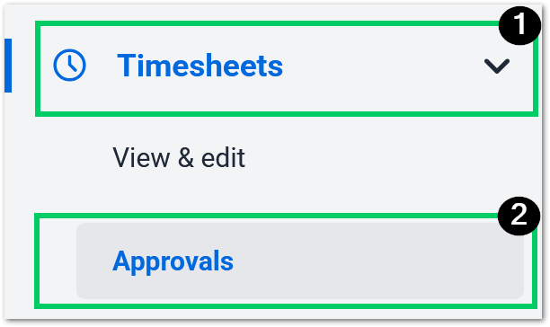

- Within the approvals page, you’ll be able to see:
- Pay period
- Regular tracked hours
- Manual time (should be empty unless agreed with manager)
- Activity percentage
- Timesheet status
- Screenshots taken
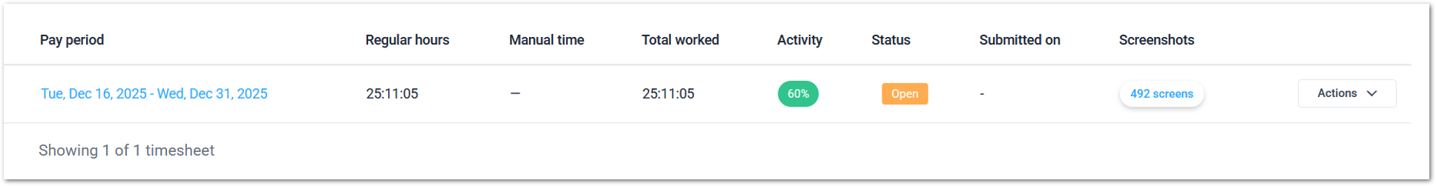

- In the timesheet, select Actions > Submit.
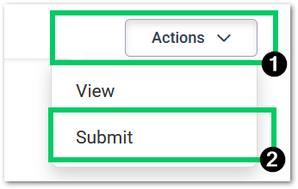

- Once you reviewed your hours, confirm the timesheet submit.
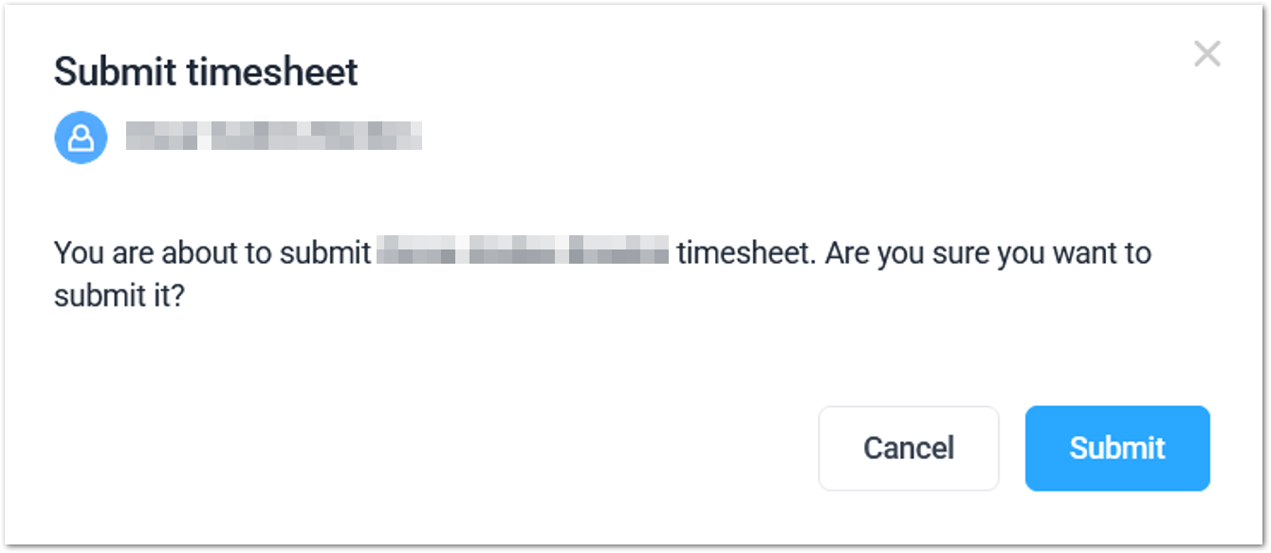

- In the submitted tab, you will see that your timesheet has changed status to Submitted, and it’s now waiting for approval.
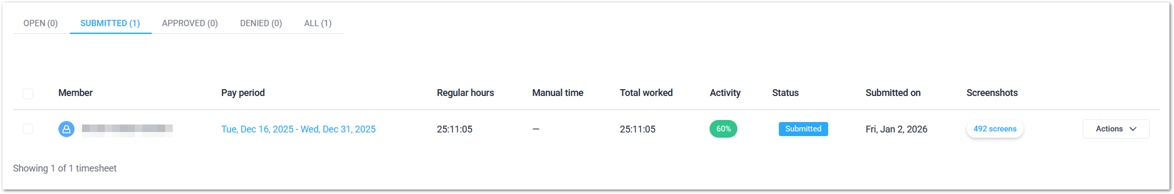

- Once your timesheet has been approved, you will see the status change to Approved in the corresponding tab.
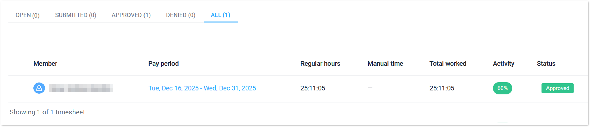
Tip: At this point, all it’s left to do is to create and send your invoice to ZTERS for payment.

CREATE INVOICE FOR PAYMENT
This section outlines the process for creating an invoice in Hubstaff based on approved timesheets. It details how contractors generate invoices using validated tracked time, verify billing information, and submit the invoice to ZTERS for payment.
Note: Only approved timesheets may be invoiced, and accurate invoice creation is essential to ensure timely and correct compensation.

Invoice creation based on Timesheet
- Go to your Hubstaff dashboard
- In the left side panel, select the Invoices page on the web dashboard. Then select the New Invoice button.
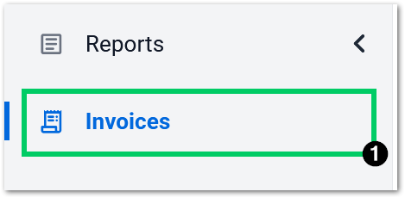

- In the new invoice window, select Generate line items to add the timesheet tracked time in the invoice.
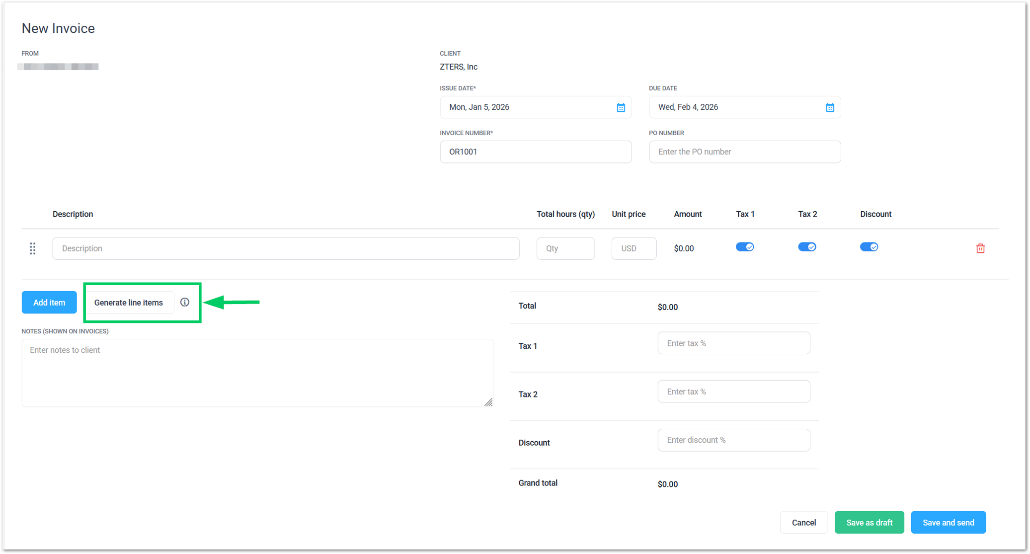

- In the pop-up window, add the following information and select Generate.
- Date Range: Select the date range for the invoice period using the calendar.
- Projects: Select the projects/meetings in which you worked from the list.
- Member: Automatically selected.
- Line Items: Select By timesheet.
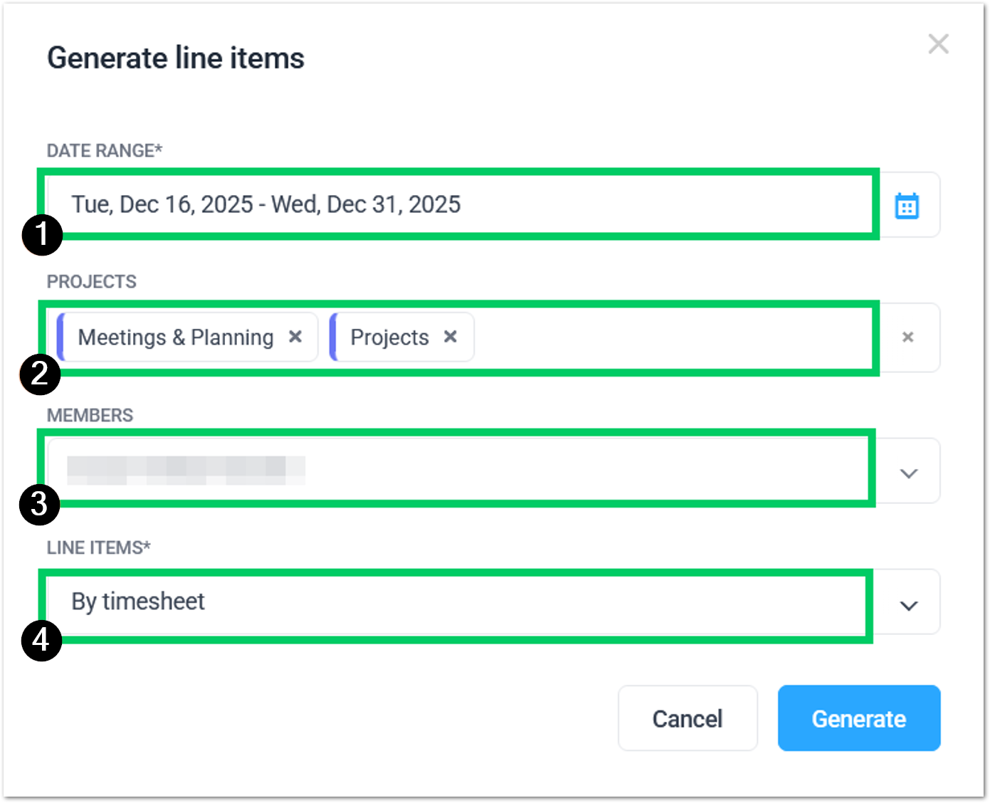
Warning: It’s critical to select “By timesheet” in the last line. This ensures the invoice time is added automatically. Otherwise, you will have to add the time manually.

- You will see the timesheet added for the invoice, with information about your payment. This timesheet will be used to create the invoice.
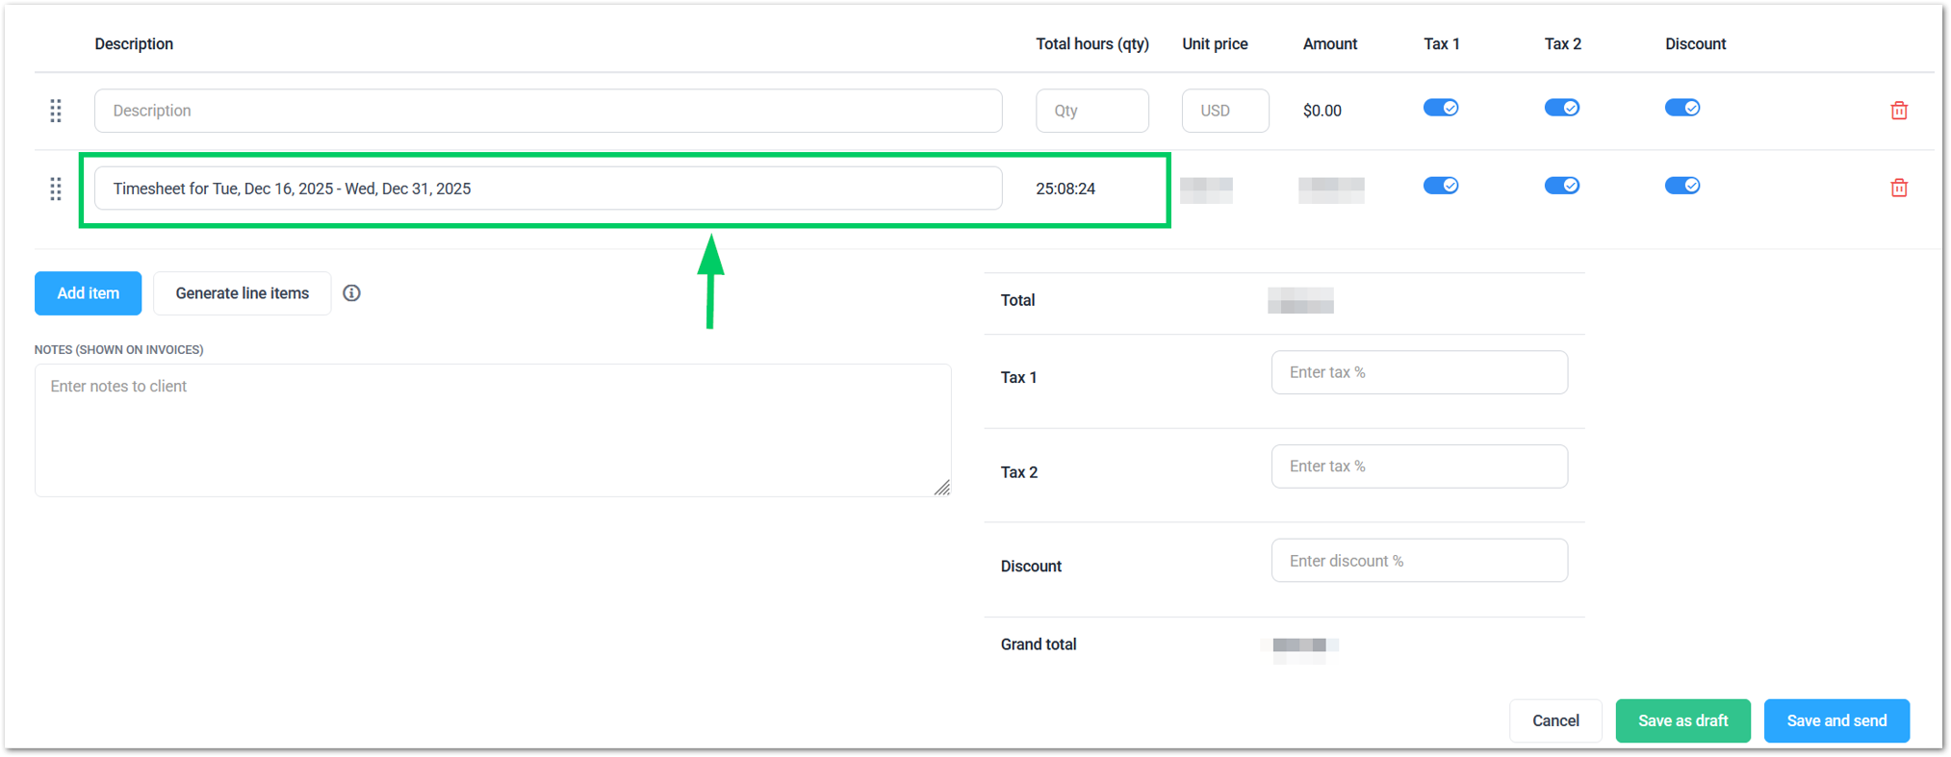
Tip: If the unit price column is empty, enter the pay rate agreed with ZTERS. Make sure the number is correct, otherwise your invoice will be rejected (e.g. 20 USD/hour).

- Check the Grand Total amount that you’ll receive. The tax 1, tax 2, and Discount fields must be empty unless ZTERS tells you otherwise.
- Once everything is correct, select the Save and send button.
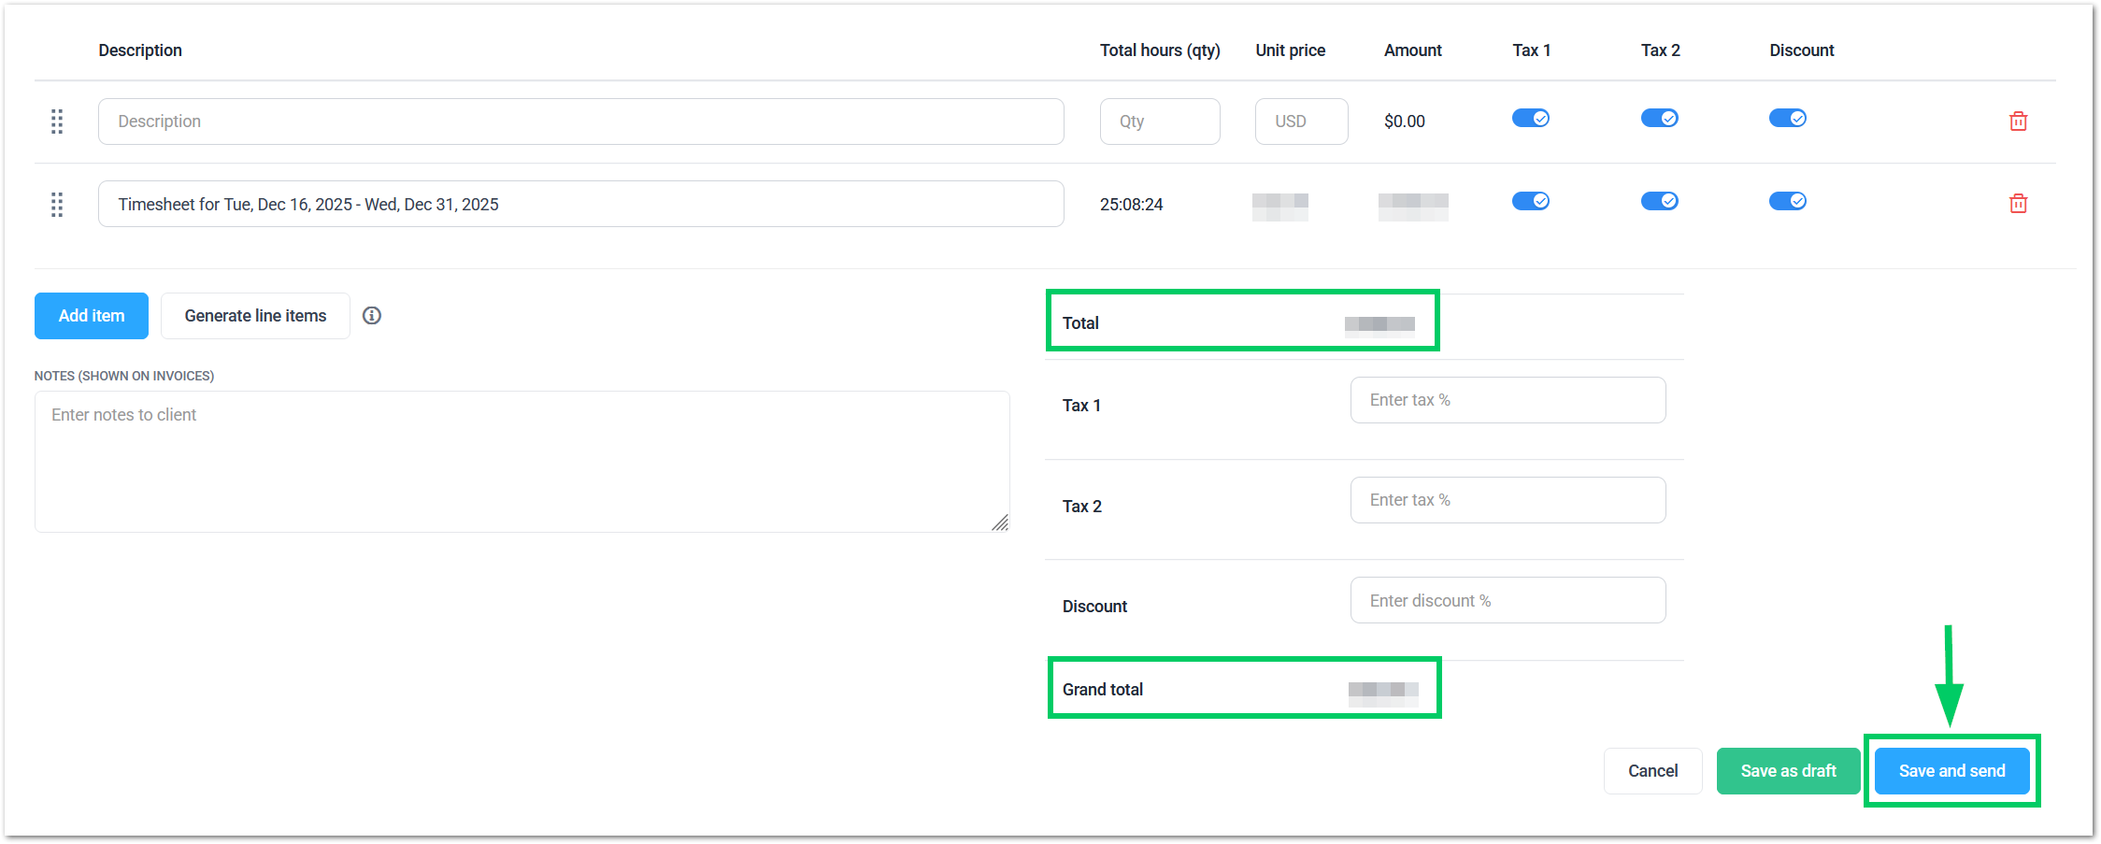

- Hubstaff will pop up a window with a summary of your invoice request to ZTERS. Make sure everything is correct and select Send.
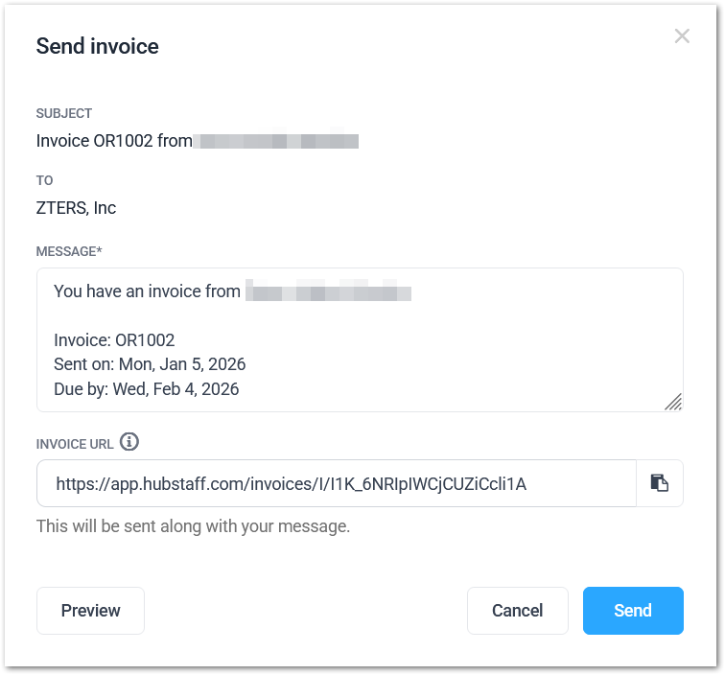

- The invoice will be sent with the amount due.
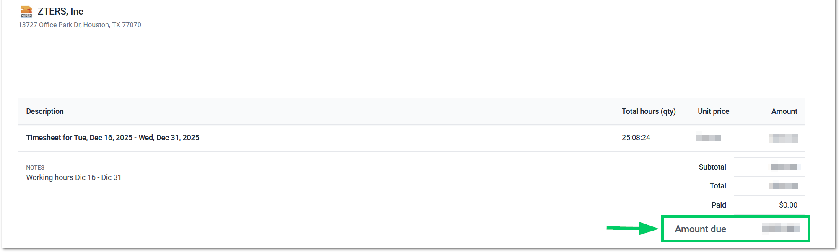
Tip: After sending the invoice, please send the message “sent” in the ZTERS invoice group in Microsoft Teams. So, everyone knows that you have completed this process.

- You can always verify the status of your invoices via Invoices > All Statuses.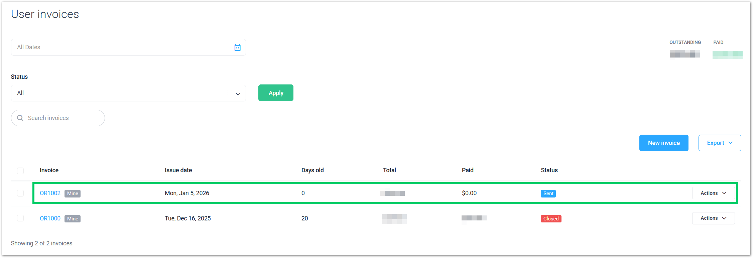

APPROVAL SIGNATURES
Digital signature blocks below are formatted for DocuSign / Adobe Sign.
Role | Name | Digital Signature Block | Date (dd/mm/aa)
Digital Development Manager | Anthony Bures |  | 09/01/2026

--- END OF THE DOCUMENT ---

